Mrs. Sturgis
Email: ksturgis@newpaltz.k12.ny.us

Welcome to 8th Grade Art….

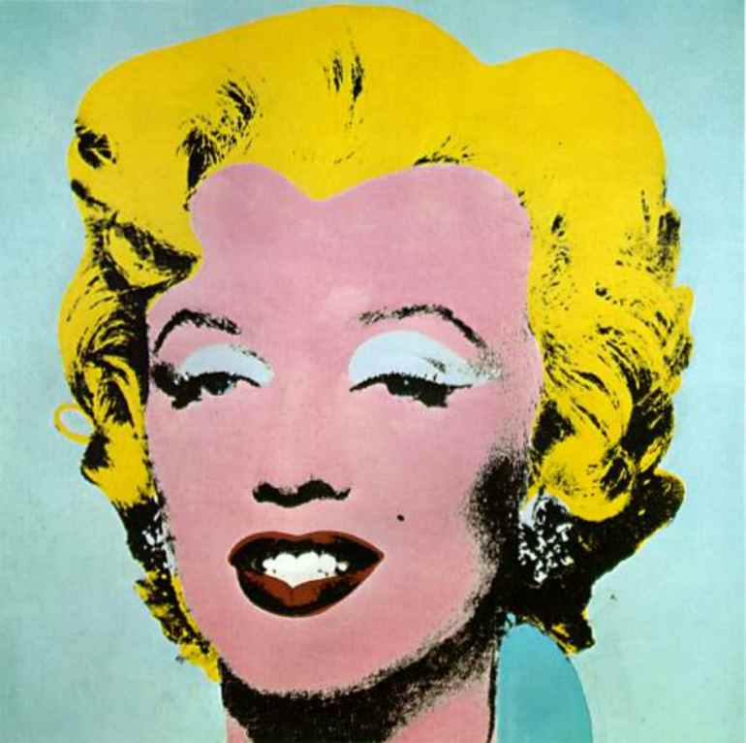

Marilyn Monroe 1967 by Andy Warhol

Goals:

To research and study Art Careers.

To identify and study the Elements of Art.
- To study art from a more contemporary perspective.
- To create art inspired by art movements studied.

Topics to be explored and Planned Projects for the current school year:
- The Elements of Art
- Art Careers
- Study of Optical Illusions and Art History
- Study of the Pop Art movement
- Conceptual Art/Contemporary Art

Grades:

Grades for each project will be based on a point system. Project
Rubrics are based on the following categories:
- Elements of Art and Principles of Design as they relate to each individual project
- Creativity
- Effort
- Craftsmanship

Each project will have a specifically designed rubric with clear expectations.
Class effort is the most influential factor in each one of these categories.

